Openshift Exercise Basic Commands
oc login -u admin -p redhatocp https://api.ocp4.example.com:6443 oc get projects
oc get nodes
oc get nodes -o wide
oc get nodes --show-labels oc describe node worker01
oc get node worker01 -o yaml > node.yaml
#Open node.yaml and see the content and exit from the file# oc get pods --all-namespaces
oc get pods -A -o wide
oc get pods -A -o wide --show-labels oc label node worker01 disk=ssd
oc get nodes --show-labels oc get nodes -L disk
oc get nodes -l disk=ssd
oc label node worker01 disk-

POD EXERCISE
vim pod.yaml make sure that there are no spaces mistakes.
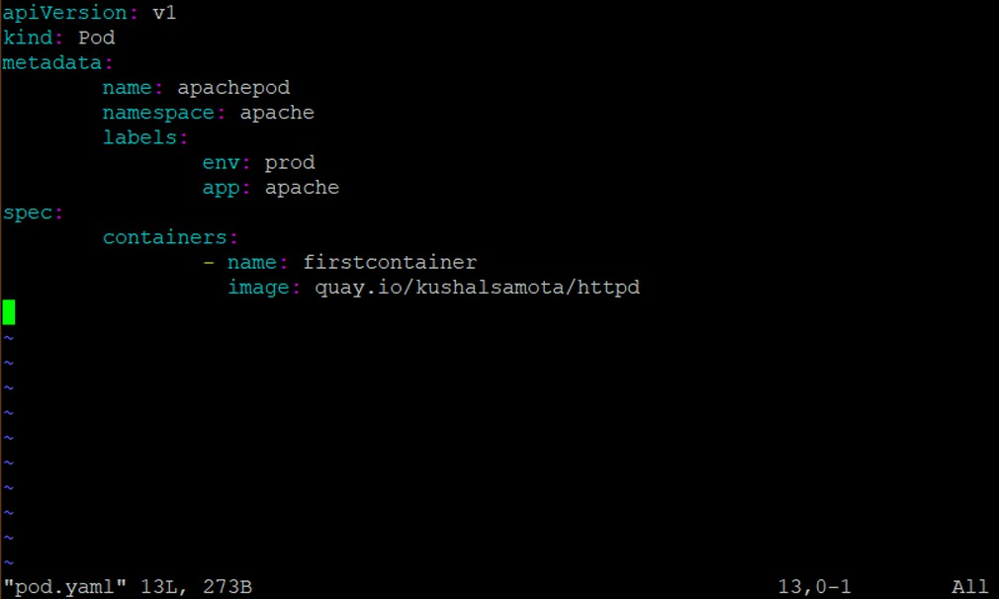

=====================================
oc new-project apache oc create -f pod.yaml oc get pods -n apache
oc get pods -o wide -n apache
oc get pods --show-labels -n apache oc describe pod apachepod -n apache oc logs apachepod
oc get pod apachepod -o yaml -n apache > pod1.yaml vim pod1.yaml
exit from file
oc delete pod apachepod -n apache oc get pods -n apache

#########################################################

MULTI CONTAINER POD EXERCISE
vim pod.yaml make sure that there are no spaces mistakes.
===========================================
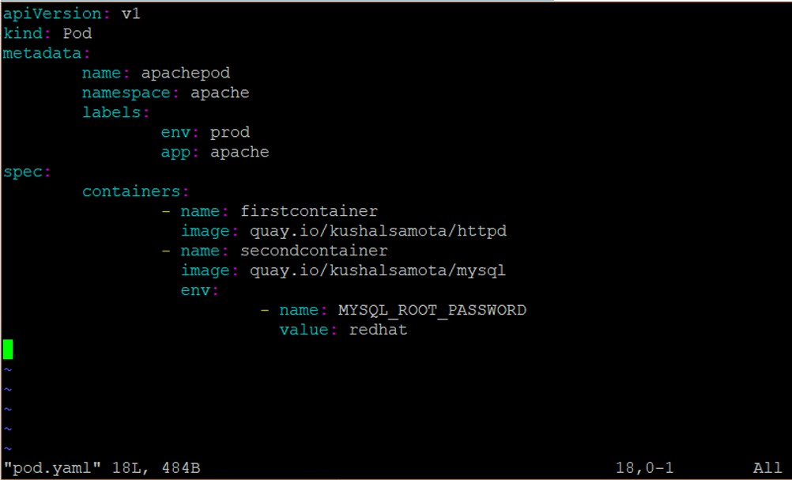

==============================================
save the file
oc create -f pod.yaml
oc get pods -n apache === two container will be running in a pod oc get pods -o wide -n apache
oc describe pod apachepod -n apache oc exec -it apachepod bash -n apache exit
oc exec -it apachepod -c secondcontainer bash -n apache exit
oc logs apachepod -c firstcontainer -n apache oc logs apachepod -c secondcontainer -n apache oc delete pod apachepod -n apache
oc get pods -n apache

##################################################

POD WITH VOLUME(EMPTY DIR) EXERCISE
vim pod.yaml make sure that there are no spaces mistakes.
=============================================
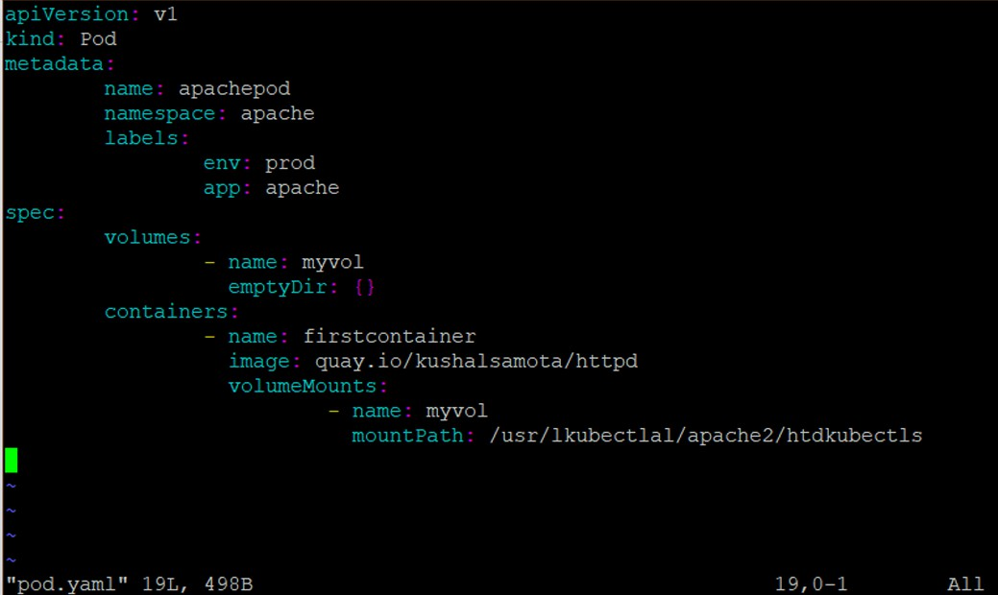

========================================
oc create -f pod.yaml
It will give you the error as the mount path is wrong.
Edit the pod.yaml again and change the mount path to /usr/local/apache2/htdocs oc apply -f pod.yaml
oc get pods -n apache
oc describe pod apachepod -n apache oc delete pod apachepod -n apache

#########################################

REPLICA SET EXERCISE
===================================
vim rs.yaml make sure that there are no spaces mistakes.
===================================
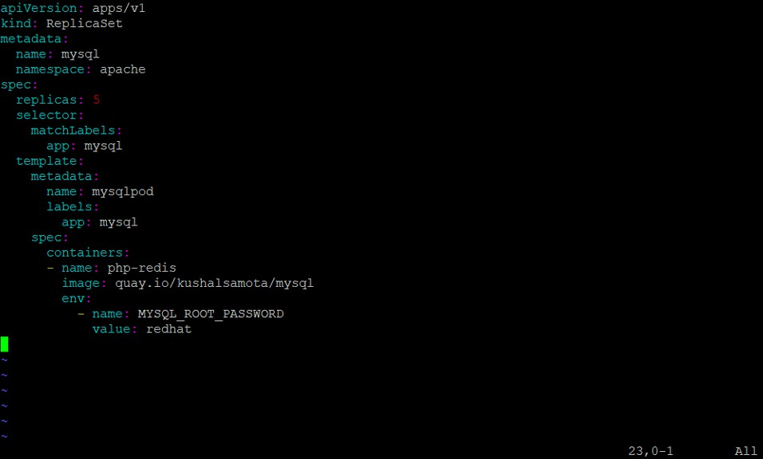

===================================
save the file
======================================

oc create -f rs.yaml oc get all -n apache
oc scale rs/mysql --replicas=5 -n apache oc get pods -n apache
oc scale rs/mysql --replicas=1 -n apache oc get pods -n apache
oc delete rs mysql -n apache oc get all -n apache

###########################################

DEPLOYMENT EXERCISE
vim dep.yaml make sure that there are no spaces mistakes.
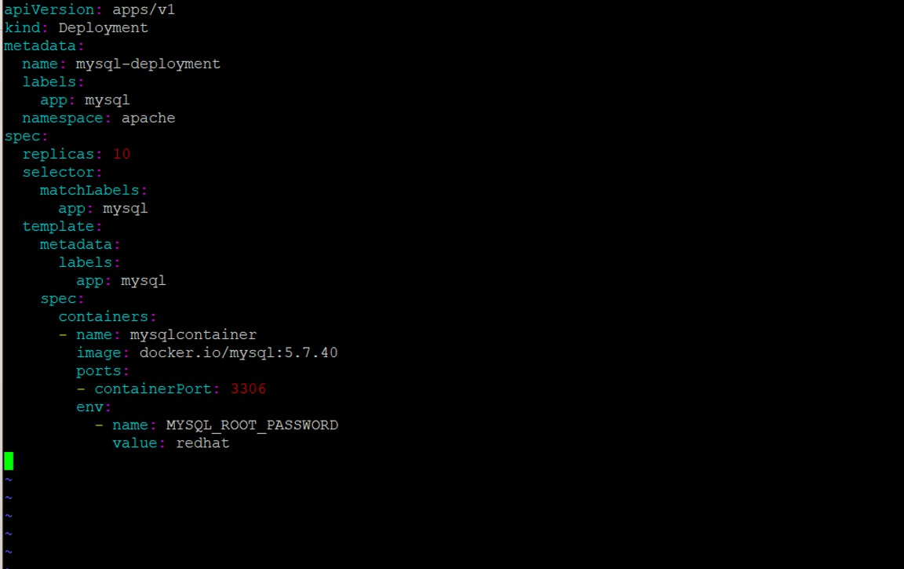

oc create -f dep.yaml
oc scale deployment/mysql-deployment - -replicas=3 -n apache oc get all
#It might give you an error as the images from docker.io gives pull rate limit error. oc delete deployment mysql-deployment
#Open dep.yaml file and change the image path to quay.io/kushalsamota/mysql

oc apply -f dep.yaml oc get all -n apache
oc set image deployment mysql-deployment mysqlcontainer=quay.io/kushalsamota/mysql -record -n apache
oc rollout history deployment mysql-deployment -n apache oc get all -n apache
oc rollout history deployment mysql-deployment -n apache oc get all -n apache
oc rollout undo deployment mysql-deployment --to-revision=1 -n apache oc rollout history deployment mysql-deployment -n apache
oc delete deployment mysql-deployment -n apache

###############################################

SECRET EXERCISE
vim dep.yaml make sure that there are no spaces mistakes.
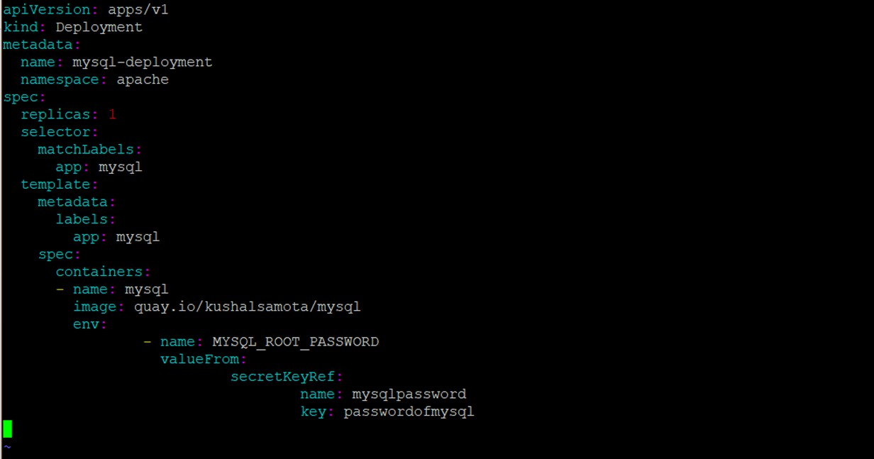

oc create secret generic mysqlpassword --from-literal=passwordofmysql=redhat –n apache
oc create -f dep.yaml oc get pods –n apache
oc describe deployment mysql-deployment -n apache oc describe secret mysqlpassword -n apache
oc delete deployment mysql-deployment -n apache

oc delete secret mysqlpassword -n apache

#####################################

CONFIGMAP EXERCISE
vim dep.yaml make sure that there are no spaces mistakes.
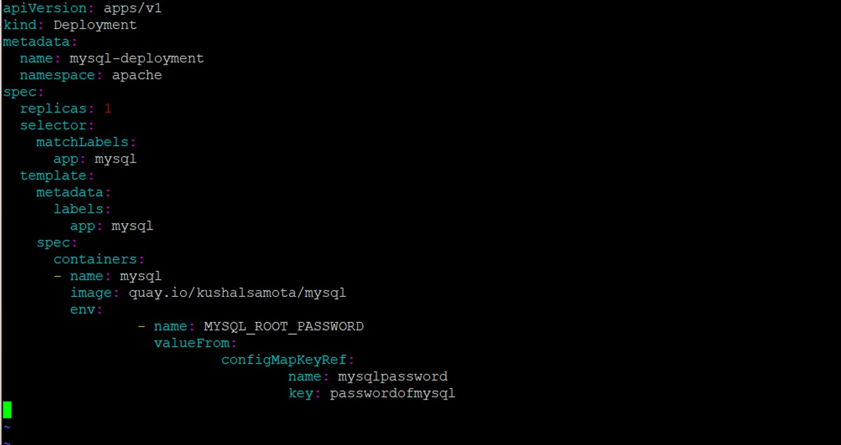

oc create configmap mysqlpassword --from-literal=passwordofmysql=redhat –n apache oc get configmap -n apache
oc get pods –n apache
oc describe configmap mysqlpassword -n apache oc create -f dep.yaml
oc describe deployment mysql-deployment -n apache oc delete deployment mysql-deployment -n apache oc delete configmap mysqlpassword -n apache
oc delete project apache

